Students can configure messaging outputs and customize them for their profile.

Navigate to the Settings block and select *My profile > Messaging*.

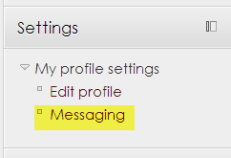

The *Configure notification methods for incoming messages* page is a grid of message outputs across the top row and message types listed below. The intersection of particular output and type contains default preferences for chosen messaging type and output.

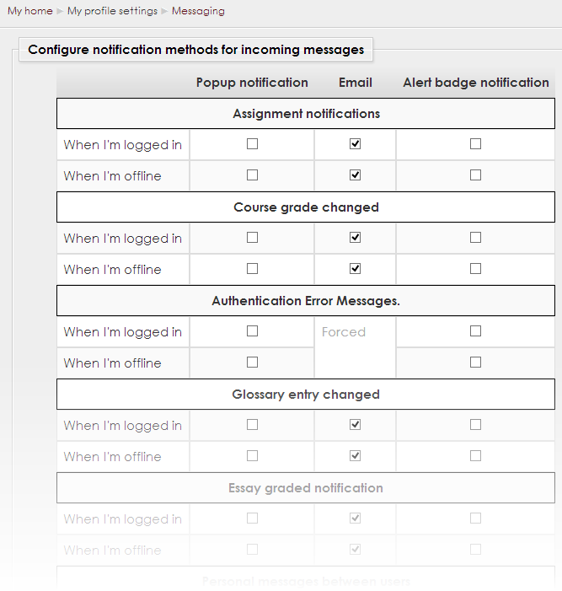

There are currently 3 types of output:

* **Popup notification:** messages that grab the student’s attention immediately in order for them to take action. Messages pop-up from the bottom of the screen.
* **Email:** communicates information to the student when they are offline mostly and a student needs to interact with the communication outside of NCOnline. Messages are sent to the students’ email addresses.
* **Alert badge notification:** communicates information that a student should be allowed to determine if they view it now or later; there is no requirement that they read it now. Messages are sent via the alert badge at the top of the page.

When to receive messages:

* **When I’m logged in:** When checked, will send the message via the selected output type when a student is logged in NCOnline.
* **When I’m offline:** When checked, will send the message if the student is not logged into the system and will be displayed when the student logs back in.

The different outputs are defined below:

* **Assignment notifications:** Notification sent to student informing that an assignment has been graded by the Teacher.
* **Course grade changed:** Notification sent to the manager, instructor and student informing that the course grade has changed for a student.
* **Glossary entry changed:** Notification sent to instructors and all students except the one that edited the glossary entry, informing that the glossary entry has changed.
* **Essay graded notifications:** Notification sent to students informing that an essay has been graded.
* **Personal messages between users:** Notifications sent to and from all roles with personal messages.
* **Joule Gradebook messages:** Notifications sent to students from an instructor through the Joule Gradebook.
* **Activity updated or added** Notifications sent to all roles informing that an activity in the course has been updated or added.
* **Activity completed:** Notifications sent to students informing that activities have been completed.
* **Activity graded:** Notifications sent to students informing that their instructor has graded an activity.
* **Subscribed forum posts:** Notifications sent to all roles if subscribed to a forum that there has been a post or comment.

**Temporary disable notifications:** Temporarily disables all notifications except those marked as “Forced”.

Click *Update profile*at the bottom of the page to save your changes.