WINTER QUARTER 2016
The online bookstore will go live on December 1st. After this date you will be able to purchase your textbooks online. You will need to be registered for classes and have a voucher code (if eligible). If you are unsure about being eligible for a voucher code, you should contact the Financial Aid office to ask. Credit card payments are also accepted.

Once you have your class schedule and your voucher code, go to the website below to create a bookstore account and order your books.

Website: www.nc.textbookx.com
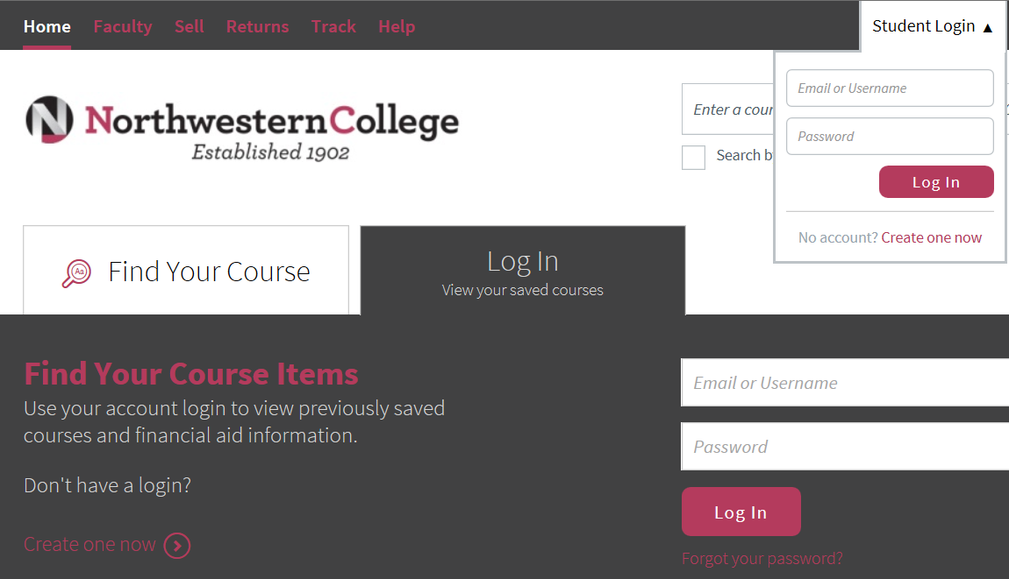

Select “Create one now” to begin creating your bookstore account.
You will be prompted to:
- Create a username and password (add a number to differentiate your username).
- Provide an email address (alerts, shipping notifications and order confirmations will be sent to this email address).
- Provide a shipping address (textbooks will be sent to this address).
- Click “Create your account” to begin ordering your textbooks.

If you need assistance ordering your textbooks: amichel@nc.edu – 773-777-4220 ext. 2240

